NALAIYA THIRAN ASSIGNMENT-1

**USER CASE:** IOT Based Safety Gadget for Child Safety Monitoring and Notification.

**Team ID :** PNT2022TMID54268

**NAME :** HARIKRISHNAN R

**Make a Smart Home in Tinkercad using 2+ sensors, LED, Buzzer in single code and circuit.**

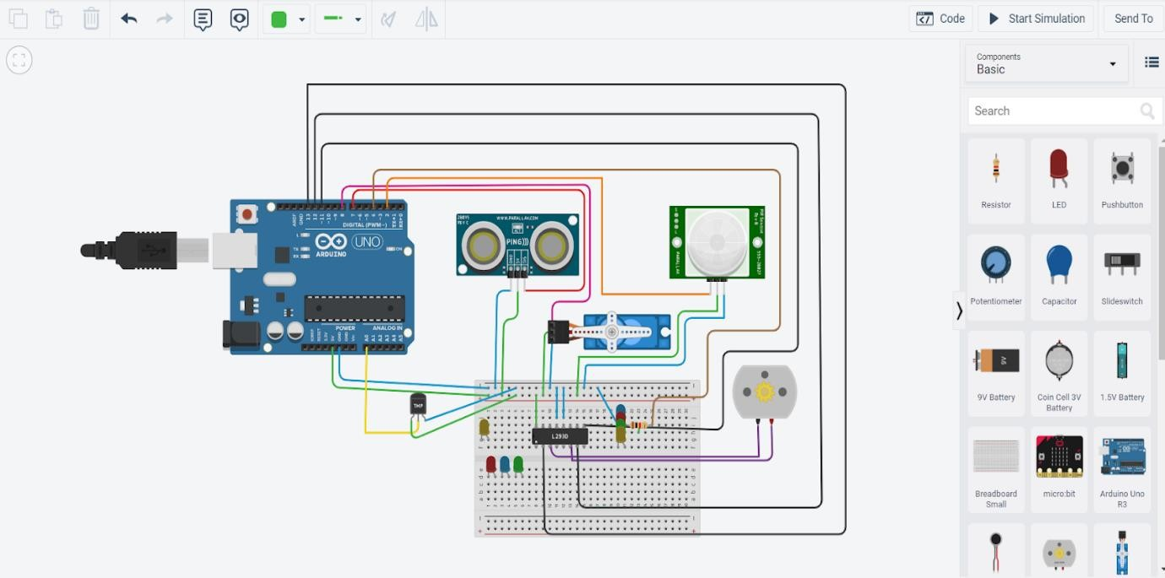

**CODE:**

#include<Servo.h> const int pingPin = 7; int servoPin = 8; Servo servo1;

void setup() {

*// initialize serial communication:* Serial.begin(9600); servo1.attach(servoPin); pinMode(2,INPUT); pinMode(4,OUTPUT); pinMode(11,OUTPUT); pinMode(12,OUTPUT); pinMode(13,OUTPUT); pinMode(A0,INPUT); digitalWrite(2,LOW); digitalWrite(11,HIGH);

}

void loop() {

long duration, inches, cm; pinMode(pingPin, OUTPUT); digitalWrite(pingPin, LOW); delayMicroseconds(2); digitalWrite(pingPin, HIGH); delayMicroseconds(5); digitalWrite(pingPin, LOW);

*// The same pin is used to read the signal from the PING))): a HIGH pulse*

*// whose duration is the time (in microseconds) from the sending of the ping*

*// to the reception of its echo off of an object.*

pinMode(pingPin, INPUT); duration = pulseIn(pingPin, HIGH);

*// convert the time into a distance*

inches = microsecondsToInches(duration); cm = microsecondsToCentimeters(duration);

*//Serial.print(inches);*

*//Serial.print("in, ");*

*//Serial.print(cm);*

*//Serial.print("cm");*

*//Serial.println();*

*//delay(100);* servo1.write(0); if(cm < 40)

{

servo1.write(90); delay(2000);

}

else

{

servo1.write(0);

}

*// PIR with LED starts*

int pir = digitalRead(2); if(pir == HIGH)

{

digitalWrite(4,HIGH); delay(1000);

}

else if(pir == LOW)

{

digitalWrite(4,LOW);

}

*//temp with fan*

float value=analogRead(A0); float temperature=value*0.48;

Serial.println("temperature"); Serial.println(temperature);

if(temperature > 20)

{

digitalWrite(12,HIGH); digitalWrite(13,LOW);

}

else

{

digitalWrite(12,LOW); digitalWrite(13,LOW);

}

}

long microsecondsToInches(long microseconds) { return microseconds / 74 / 2;

}

long microsecondsToCentimeters(long microseconds) { return microseconds / 29 / 2;

}